ØØ Explanation :
- A digit BCD number is available at memory location D000 H. We have to unpack this BCD number i.e. we have to separate the BCD digits. e.g. : If the number = 92 H then in unpack form the two digits will 02 H and 09 H.
- We have to mask the lower nibble, first and rotate four times to the right to get the MSB digit.
- Then to get the LSB digit mask the upper nibble.
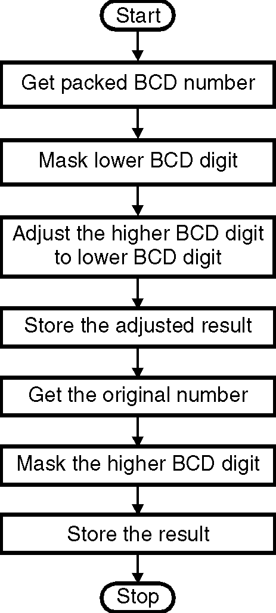
- Store the result.
- Masking lower nibble means ANDing the number
with 0F0 to get MSB.
ØØ Algorithm :
Step I : Load unpacked number into register A.
Step II : Mask the lower nibble.
Step III : Rotate 4 times right to make MSB digit = LSB.
Step IV : Store the digit at memory location D001 H.
Step V : Load number in A.
Step VI : Mask upper nibble.
Step VII : Store the result at memory location D002 H.
Step VIII : Stop.
ØØ Flowchart : Refer flowchart 25.
ØØ Program :
Instruction Comment
LDA D000H ; Get the packed BCD number in register A
ANI 0F0H ; Mask lower nibble
RRC ; Make MSB BCD digit = LSB digit
RRC Flowchart 25
RRC
RRC
STA D001H ; Store the partial result
LDA D000H ; Get the original BCD number in register A
ANI 0FH ; Mask higher nibble
STA D002H ; Store the result
HLT ; Terminate program execution

